**Title**: **The role of performance management in promoting organizational learning and development case study of Nigerian Hospitality industry.**

# Data Analysis and Result Discussion

## 4.1 Introduction

This chapter aims to analyze the role of performance management in promoting organizational learning and development within the context of the Nigerian hospitality industry. The hospitality industry plays a crucial role in the economic growth of Nigeria, and effective performance management can contribute significantly to the industry's success. Through a case study approach of the Nigerian hospitality industry, this research will explore how performance management practices influence organizational learning and development in selected hospitality establishments. The findings will provide insights into the strategies employed, challenges faced, and outcomes achieved, ultimately contributing to a better understanding of the relationship between performance management and organizational growth in the Nigerian hospitality sector.

## 4.2 Understanding the Dataset

Google Forms surveys were used to collect data for this study on performance management's function in organizational learning and growth in the Nigerian hotel industry. This method collected quantitative and qualitative data from hospitality workers of various roles and degrees. The performance management, organizational learning, and development questionnaire was carefully created. Questions may have covered employee performance appraisal, goal-setting, training and development, feedback, and how performance management affects learning and growth. The use of Google Forms made data collection, questionnaire distribution, and answer analysis easy. A study on the Nigerian hospitality business, which is presumably geographically distributed, benefits from this technique. Data visualization and interpretation tool Power BI will evaluate the collected dataset. Data patterns, trends, and relationships can be seen using charts, graphs, histograms, and other visualizations created by the application. Complex datasets can be explored and presented with Power BI's user-friendly interface and interactive capabilities.

### 4.2.1 Demographic Characteristics of Respondents

The table below shows the percentage rate of respondent’s demography questions such as their gender, age group, Job positions and their years of experience. The table below give more details of the information.

Table 4.1 Respondent’s demographic response

|  |  |  |
| --- | --- | --- |
|  |  | Frequency/percentage |
| GENDER | Female  Male | 74.44%  25.56% |
| Age group | 18-24  25-34  35-44  45-54 | 21.11%  59.44%  17.78%  1.67% |
| Educational Qualification | Bachelor's degree  Doctoral degree  Master's degree  SSCE | 71.67%  1.67%  26.11%  0.56% |
| Years of Experience in Airtel | 1-3 years  4-6 years  Less than 1 year | 61.67%  36.11%  2.22% |
| Job Position | Food and Beverage  Front Desk/Reception  Housekeeping  Human Resources  Management/Supervisory | 5.00%  10.00%  7.78%  48.33%  28.89% |
| Size / Number of Employees | 101-200  50-100  Less than 50 | 38.33%  58.33%  3.33% |

### 4.2.2 Questionnaire Response Rate

The response rate for the administered questionnaires in this study was 81.8%. Out of a total of 220 questionnaires distributed, 180 were completed and retrieved successfully, indicating a high level of engagement and participation from the surveyed population. Notably, there were no invalid questions, suggesting that the data collected was of good quality and reliability. This response rate reflects a robust and comprehensive dataset that can be used for meaningful analysis and insights in the research context.

Table 4.2 Response Rate

|  |  |  |
| --- | --- | --- |
|  | Number | Percentage |
| Total number of administered questionnaires | 220 | 100% |
| Number of completed and retrieved questionnaires | 180 | 81.8% |
| Number of invalid questions | 0 | 0% |
| Number of valid questions | 180 | 81.8% |

## 4.3 Content validity: Hypothesis Test

The test carried out was a test to validate and seek for relationships between variables from the data gathered. It aimed at identifying relationships and test for assumptions in the data if they are true or not. It also aimed to facilitate pattern recognition and hypothesis generation, allowing the identification of unexpected correlations or trends in the data and formulate more targeted research questions for further investigation, ultimately guiding the direction of the research process.

### 4.3.1 Content Validity: Hypothesis Test 1

This study aimed to examine whether a relationship exists between the years of experience of respondents and the type of hospitality industry they are employed in. The data was transformed using MS Excel, and a p-value was computed. The chosen significance level (α) was set at 0.05. If p-value ≤ 0.05, the null hypothesis (H0) will be rejected in favor of the alternative hypothesis (H1) Conversely, if the p-value exceeds α, the null hypothesis will be upheld.

Null and Alternative Hypotheses:

H0: There is no significant relationship between the years of experience of respondents and the type of hospitality industry they work in.

H1: There is a significant relationship between the years of experience of respondents and the type of hospitality industry they work in.

Table 4.3 Observed values for Hypothesis Test 2

|  |  |  |  |  |
| --- | --- | --- | --- | --- |
| **Count of Years of Hospitality Experience** | **Column Labels** |  |  |  |
| **Row Labels** | **1-3 years** | **4-6 years** | **Less than 1 year** | **Grand Total** |
| Guest House | 3 | 4 |  | 7 |
| Hotel | 53 | 24 | 1 | 78 |
| Resort | 23 | 22 | 1 | 46 |
| Restaurant | 32 | 15 | 2 | 49 |
| **Grand Total** | **111** | **65** | **4** | **180** |

Table 4.4 Expected Values for Hypothesis Test 1

|  |  |  |  |  |
| --- | --- | --- | --- | --- |
| Count of Years of Hospitality Experience | Column Labels |  |  |  |
| Row Labels | 1-3 years | 4-6 years | Less than 1 year | Grand Total |
| Guest House | 4.316666667 | 2.52778 | 0.2 | 7.0 |
| Hotel | 48.1 | 28.1667 | 1.7 | 78.0 |
| Resort | 28.36666667 | 16.6111 | 1.0 | 46.0 |
| Restaurant | 30.21666667 | 17.6944 | 1.1 | 49.0 |
| Grand Total | 111 | 65 | 4 | 180 |

The figure 4.1 The ratio of the years of experience of respondents in each hospitality establishment.

#### Calculating the p-value.

The p-value was calculated using excel CHITEST with the observed and expected values. A p-value of 0.0346853797 was obtained. As this value is less than 0.05, H0 is rejected and H1 is adopted, indicating that there is a significant relationship between the years of experience of respondents and the type of hospitality industry they work in.

### 4.3.2 Content Validity: Hypothesis Test 2

This study aimed to examine whether a relationship exists between the years of experience of respondents and their familiarity with the use of performance management in organizations i.e. does their number of experiences a major factor influencing their familiarity with how performance management in an organization can increase learning. The data was transformed using MS Excel, and a p-value was computed. The chosen significance level (α) was set at 0.05. If p-value ≤ 0.05, the null hypothesis (H0) will be rejected in favor of the alternative hypothesis (H1) Conversely, if the p-value exceeds α, the null hypothesis will be upheld.

Null and Alternative Hypotheses:

**H0:** There is no significant relationship between the years of experience of respondents and their familiarity with the use of performance management in organizations

**H1:** There is a significant relationship between the years of experience of respondents and their familiarity with the use of performance management in organizations

Table 4.5 Observed Value for Hypothesis Test 2



Table 4.6 Expected Values for Hypothesis Test 2

|  |  |  |  |  |
| --- | --- | --- | --- | --- |
| **Count of Do You Have Experience in PM in hospitality?** |  |  |  |  |
| Row Labels | Familiar | Somewhat familiar | Very familiar | Grand Total |
| 1-3 years | 40.7 | 4.3 | 66.0 | 111 |
| 4-6 years | 23.8 | 2.5 | 38.6 | 65 |
| Less than 1 year | 1.5 | 0.2 | 2.4 | 4 |
| Grand Total | 66.0 | 7.0 | 107.0 | 180 |

#### Calculating the p-value.

The p-value was calculated using excel CHITEST with the observed and expected values. A p-value of 0.0100298083 was obtained. As this value is less than 0.05, H0 is rejected and H1 is adopted, indicating that there is a significant relationship between the years of experience of respondents and their familiarity with the use of performance management in organizations.

Figure 4.2 Relationship between the years of experience of respondents and their familiarity with the use of PM

The figure above shows the ratio of the years of experience of respondents and their familiarity with the use of performance management in organization.

## 4.4 Analysis on Respondent Demography

The analysis based on demographic factors within the dataset offers a comprehensive exploration of participants' perceptions regarding the role of performance management in promoting organizational learning and development in the Nigerian hospitality industry. By delving into demographic attributes such as gender, age range, job positions, years of service in the company, and the specific type of hospitality industry each participant is engaged in, a more nuanced understanding of these perceptions emerges. Gender-based insights reveal potential variations in how male and female participants view the impact of performance management on their growth trajectories. The segmentation by age range provides valuable insights into generational nuances, enabling us to grasp how different age groups perceive the connection between performance management and learning. Analyzing job positions allows for the correlation of responsibilities with perceptions, unveiling how various roles within the industry interpret the effectiveness of performance management. Participants' years of service in the company offer insights into potential shifts in perceptions over time, aiding in identifying patterns among long-serving employees and newcomers. Lastly, differentiating responses based on the type of hospitality industry underscores tailored challenges and opportunities, guiding the formulation of targeted strategies to optimize performance management's role in driving organizational learning and development across the diverse landscape of the Nigerian hospitality sector.

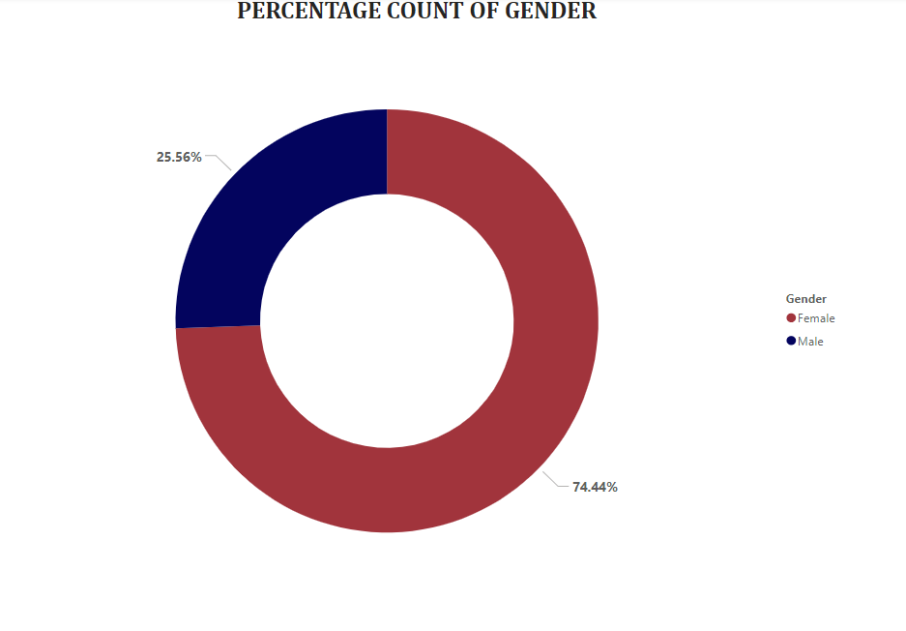

Figure 4.3 Count of gender

The visuals above show the percentage of gender that filled the research questionnaire and it can be deduce from the visuals that more response was gotten from the female compare to the male, based on the visuals 74.44%respondent are females while 25.56% of the respondent are male.

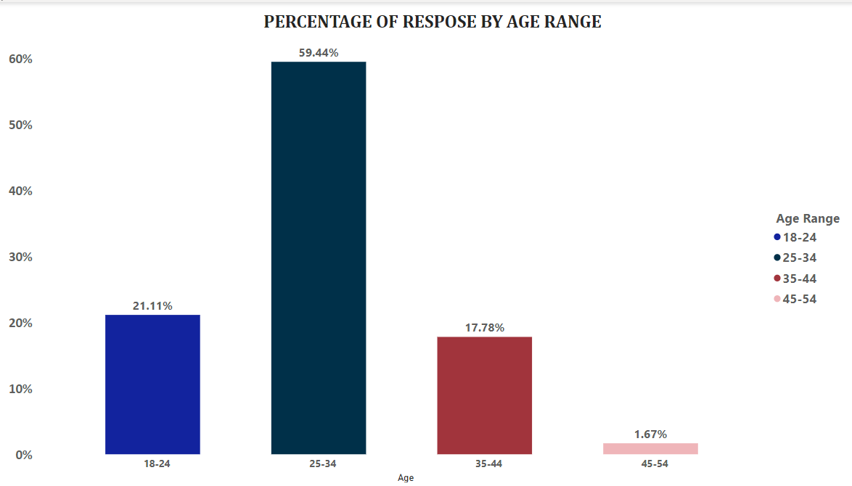

Figure 4.4 Respondents age range

The visuals above show the analysis based on the age range of respondent and it can be deduced that most of the respondent are within the age (25-34). The visuals show that 59.44% which is the majority response are with 25-34, followed by 18-24 with 21.11%, followed by 35-44 with 17.78% and lastly the age 45-54 with 1.67%. It can be concluded that the hospitality job role tends to hire people of young age than the older age.

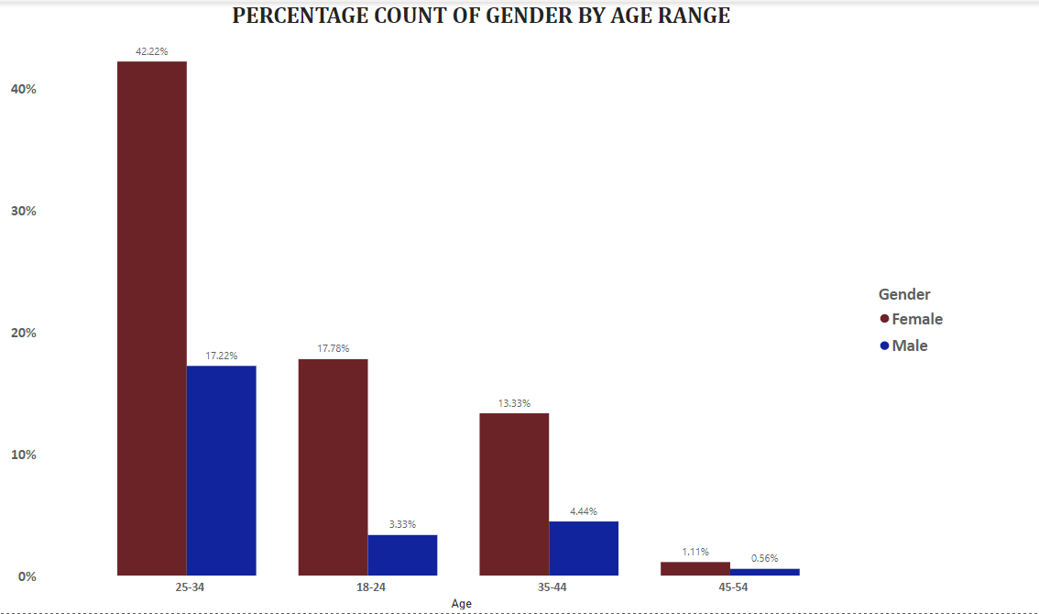

Figure 4.5 Count of gender by age range

The above visuals show the analysis of response based on gender by Age range which implies categorizing the response gotten based on gender and then grouping it by the age range. From the visual young female between the age 25-34 has the highest response with 42.22% and young male having 17.22% followed by the age 18-24 with 17.78% of female and 3.33% of male, followed by age 35-44 with 13.33% of female and 4.44% of male and age 45-54 with 1.11% of male and 0.56% of male respondent.

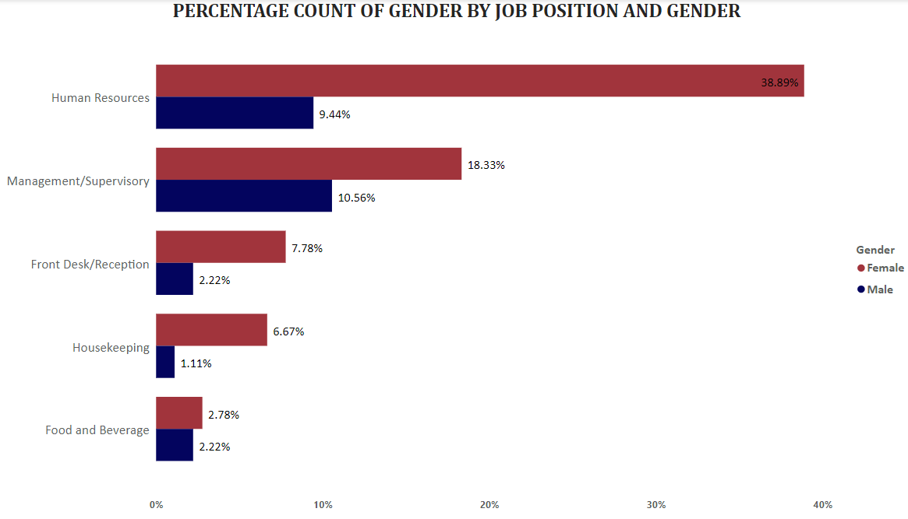

Figure 4.6 Count of gender by Job positions

The above visuals show the percentage count of respondent’s job position based on their gender and it can be deduced that most respondent are female and most respondents are from the Human Resources job position. From the analysis 38.89% of female and 9.44% of male are Human Resource workers, 18.33% female and 10.56% male works as a Management/supervisory person, 7.78% female and 2.22% works as a front desk/ receptionist, 6.67% female and 1.11% male works as a Housekeeper, while lastly 2.78% and 2.22% works in food and beverage company.

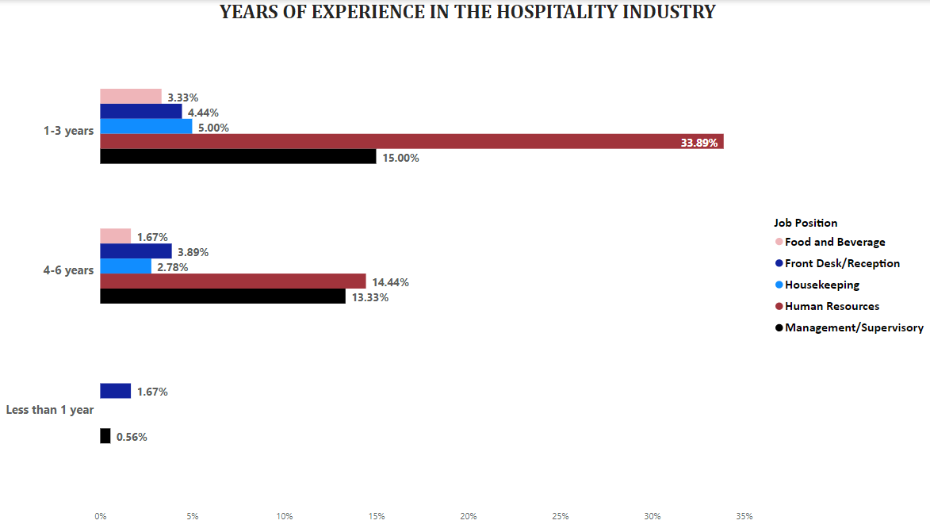

Figure 4.7 Respondents years of experience

From the above visuals the analysis tend to gather information based on how long a specific employee has experience in a job position, the it can be summarize from the visuals that most employee have 1-3years of experience stating with the job position with the highest response which is Human resources with a response percentage of 33.89%, followed by Management/ Supervisory with 15% responses, followed by Housekeeping with 5.00% responses, followed by Front desk/ Reception with 4.44% and lastly for the 1-3years of experience is Food & Beverage with 3.33% response and overall, those with 4-6 years of experience are is Human resources with a response percentage of 14.44%, followed by Management/ Supervisory with 13.33% responses, followed by Housekeeping with 2.78%% responses, followed by Front desk/ Reception 3.89% and lastly for the 1-3years of experience is Food & Beverage with 1.67% response. Finally, very few responses were gotten from those that have less than one (1) year experience with a total sum of 2.23% of response.

## 4.5 Analysis and presentation of findings on Research Question 1

*How do performance management systems in the Nigerian hospitality industry impact employee learning and development, and what factors contribute to their effectiveness or ineffectiveness?*

Performance management systems within the Nigerian hospitality industry exert a significant influence on employee learning and development. These systems serve as crucial mechanisms that shape the acquisition of skills and knowledge among employees. The impact of such systems is underscored by their ability to align individual and organizational goals, thereby fostering a culture of continuous improvement and skill enhancement. The effectiveness of these systems hinges on several factors, including clear goal-setting, regular feedback mechanisms, and tailored training programs that address the specific needs of employees in diverse roles. Moreover, leadership commitment, communication transparency, and the integration of technology play pivotal roles in determining the efficacy of performance management systems in driving employee learning and development. Conversely, their ineffectiveness may stem from inadequate communication, lack of alignment with organizational objectives, and insufficient resources allocated to training initiatives. The interplay of these factors shapes the dynamic relationship between performance management systems and the growth of employees within the Nigerian hospitality industry.

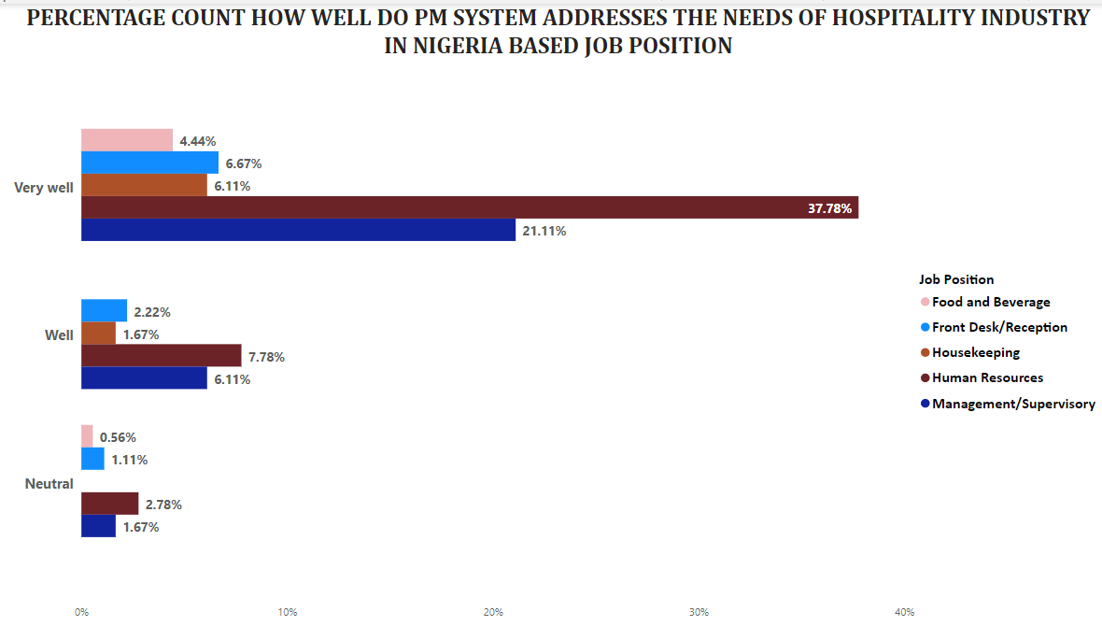

Figure 4.8 Count of how well to PM addresses the needs of hospitality industry in Nigeria

The visual representations displayed above serve as a platform for gathering insights from respondents concerning the efficacy of the Project Management system (PM) in catering to the distinct requirements of the Nigerian hospitality industry, as assessed through the lens of their respective job positions. A meticulous analysis of these visuals reveals a compelling trend: a substantial majority of respondents express a firm belief in the robustness of PM in meeting these industry needs. Impressively, an overwhelming consensus of 76.11% of respondents articulate that PM "Very Well" addresses the requisites of the hospitality sector. Furthermore, a notable contingent, totaling 17.78% of responses, assert that PM performs its role "Well," thereby contributing positively to industry demands. Meanwhile, a modest 6.12% of responses maintain a "Neutral" stance. Drawing a comprehensive inference from this analysis, it becomes apparent that PM indeed assumes a pivotal role in aptly addressing the multifaceted needs of the Nigerian hospitality industry, a conclusion supported by the collective voice of the surveyed participants.

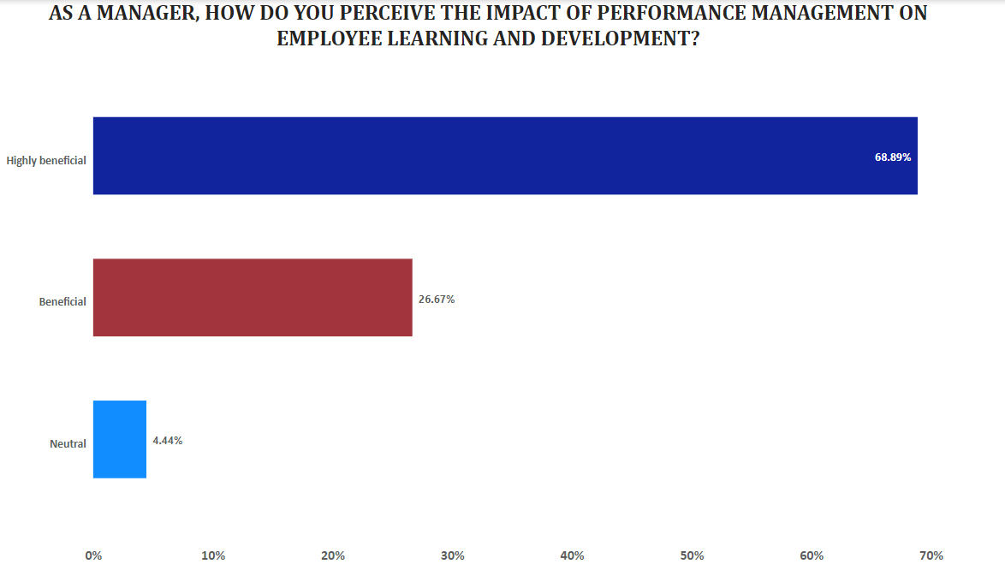

Figure 4.9 Count of how respondents perceive the impact of PM on employees learning and developments.

The visual representations presented above offer a comprehensive insight into the perceptions of managers regarding the influence of Performance Management (PM) on the learning and development of employees. Through a meticulous analysis of these visuals, a discernible pattern emerges, illuminating the prevailing sentiment among managers. Impressively, a significant majority, accounting for 68.89% of respondents, hold a firm conviction that PM wields a highly advantageous impact on the learning and development journeys of the majority of their employees. This resounding consensus is further reinforced by an appreciable segment, constituting 26.67% of responses, wherein managers express a belief in the beneficial effects of PM. In contrast, a more modest fraction, totaling 4.44% of responses, represents managers who adopt a neutral stance towards the impact of PM within their organizational context. The synthesis of these outcomes leads to a compelling and informed conclusion: the preponderance of managers firmly attests to the substantial positive influence of PM on employee learning and development, thus underscoring its pivotal role in driving growth and skill enhancement across the organizational landscape.

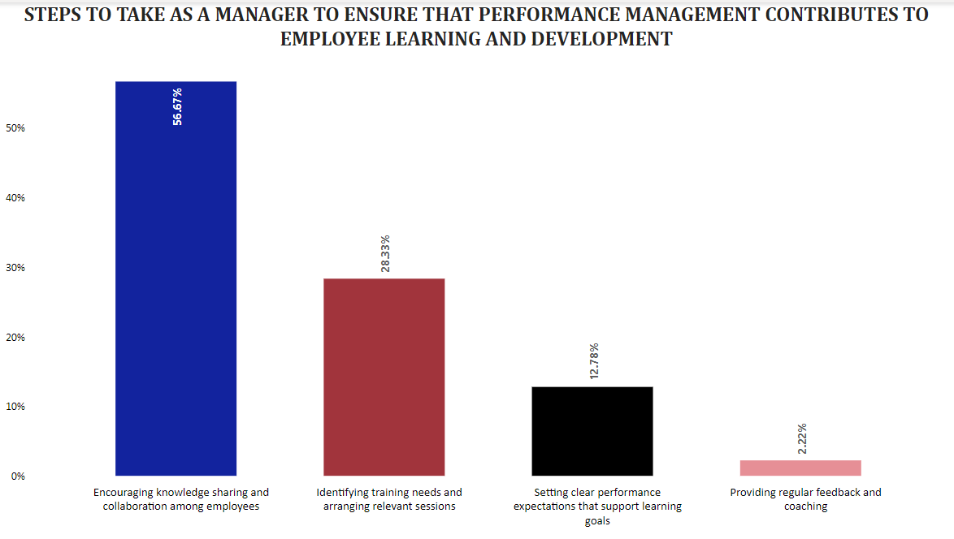

Figure 4.10 Steps managers take to ensure PM contributes to employee’s learning and development

The visual representations presented above serve as a platform for extracting insights regarding the proactive measures adopted by managers to harness the contribution of the Performance Management system (PM) toward the learning and development of employees. An in-depth analysis of these visuals reveals a distinct trend in managers' responses. Predominantly, a considerable 56.67% of managers emphasize their pivotal role in fostering a culture of knowledge sharing and collaboration among employees. This collective commitment to encouraging collective learning underscores the significance of collaborative synergy in the organization. Following closely, 28.33% of managers underscore the strategic step of identifying training needs and orchestrating targeted training sessions, amplifying the potential for skill enhancement and growth. Additionally, 12.78% of managers highlight the importance of setting lucid performance expectations aligned with learning objectives, a crucial endeavor to facilitate continuous employee development. Lastly, a notable 2.22% of managers recognize the value of providing regular feedback and coaching to employees, a nuanced approach that further bolsters their learning journey. In essence, these outcomes coalesce to illuminate the multifaceted efforts undertaken by managers, collectively emphasizing the importance of collaborative learning, targeted training, clear performance expectations, and personalized feedback, all of which contribute synergistically to the overarching goal of fostering employee learning and development through the PM system.

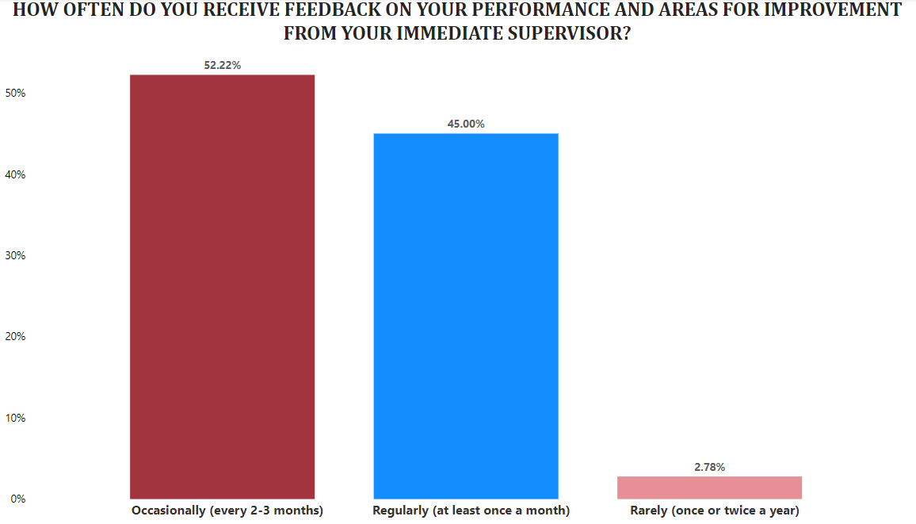

Figure 4.11 Impact of feedback on employees performance and areas of improvement

The graphical depictions provided above are instrumental in acquiring valuable insights from respondents concerning the frequency with which they receive constructive feedback for performance improvement from their immediate supervisors. A comprehensive analysis of these visuals offers a compelling conclusion: the majority of employees tend to receive feedback periodically, with a notable percentage of 52.22% indicating that feedback is dispensed on an occasional basis, occurring approximately every 2-3 months. Subsequently, a significant contingent of 45.00% attests to the regularity of feedback, affirming that they receive guidance at least once a month, underscoring the commitment to ongoing performance enhancement. In contrast, a smaller proportion, amounting to 2.78%, report receiving feedback infrequently, specifically once or twice a year. This synthesis of responses coalesces to illuminate a promising outcome: employees predominantly experience a timely provision of feedback from their immediate supervisors, thereby fostering an environment conducive to continuous improvement and performance optimization.

## 4.6 Analysis and presentation of findings on Research Question 2

*To what extent do performance management processes in the Nigerian hospitality industry align with organizational goals, and how can they be improved to better promote organizational learning and development?*

This analysis delves into the extent to which performance management processes within the Nigerian hospitality industry align with the overarching organizational objectives, while also delving into potential avenues for their enhancement to more effectively facilitate organizational learning and development. A comprehensive examination of this question seeks to unveil the synergy between performance management and organizational goals, assessing the degree to which these processes contribute to the holistic growth of the industry. By evaluating the existing alignment, potential gaps can be identified, leading to strategic insights on refining these processes. Recommendations stemming from this analysis may encompass fine-tuning performance evaluation metrics, reinforcing communication channels between management and employees, and integrating continuous learning mechanisms within the performance management framework. Ultimately, this inquiry delves into optimizing performance management to serve as a robust conduit for nurturing a culture of learning and development within the dynamic landscape of the Nigerian hospitality industry.

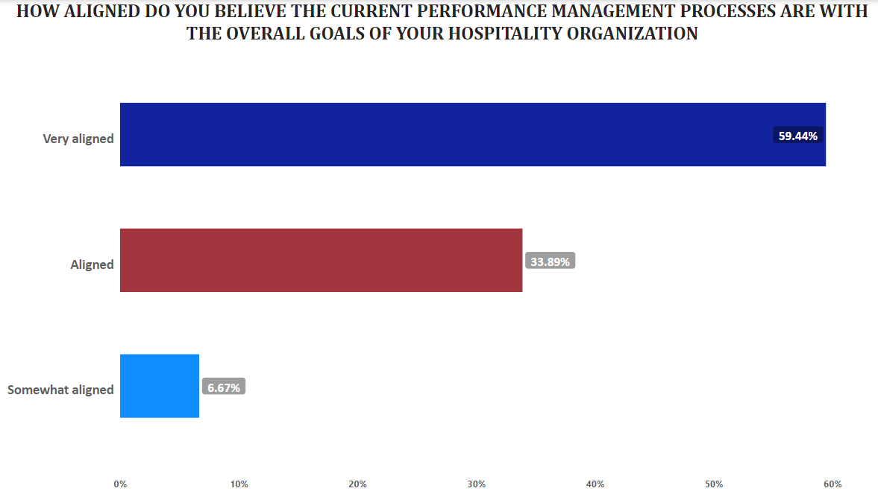

4.12 Alignment of current PM processes with the organizational goals

The visual representations provided above offer an insightful analysis of how employees perceive the alignment of their Performance Management (PM) system with the overarching goals of their respective organizations. A comprehensive examination of these visuals reveals a prevailing trend: a substantial majority of both employees and managers share a robust belief in the alignment of their organization's PM system with its overarching goals. Impressively, a noteworthy 59.44% of respondents assert a high level of alignment, categorizing it as "Very Aligned." Additionally, a considerable 33.89% of responses confirm that the PM system is indeed "Aligned" with the organizational objectives, reflecting a significant degree of harmony between performance management processes and the broader mission. Conversely, a more modest subset, constituting 6.67% of responses, express a belief that the alignment is "Somewhat Aligned." Drawing a holistic inference from this analysis, it becomes evident that a dominant consensus supports the assertion that PM systems exhibit a commendable level of alignment with the strategic goals of the organization. This prevailing sentiment underscores the pivotal role of performance management in catalyzing progress and fostering synergy towards achieving overarching organizational aspirations.

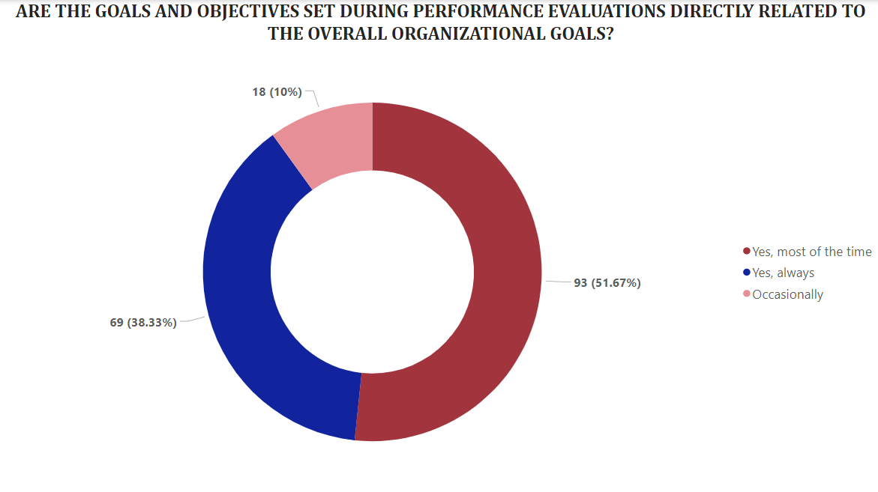

Figure 4.13 Relationship between the set goals and performance evaluation

The presented visuals above serve the purpose of investigating the correlation between the goals and objectives established during performance evaluations and their alignment with the overarching organizational goals. An insightful analysis of these visuals reveals a clear pattern: a significant majority acknowledges a substantial linkage. Evidently, a noteworthy 51.67% of respondents affirm that the goals set during performance evaluations are typically related to the organization's broader objectives, marked as "YES (Most of the time)." Furthermore, a considerable contingent of 38.33% responses attests that this alignment is consistent and robust, characterized by "YES (Always)." In contrast, a smaller yet notable fraction, comprising 10% of responses, suggests that the linkage between performance evaluation goals and organizational objectives occurs "Occasionally." The synthesis of these responses culminates in a compelling deduction: performance evaluation predominantly demonstrates a strong connection with the overarching organizational goals, underscoring the pivotal role of this process in ensuring employee efforts are optimally directed towards achieving the collective aspirations of the organization.

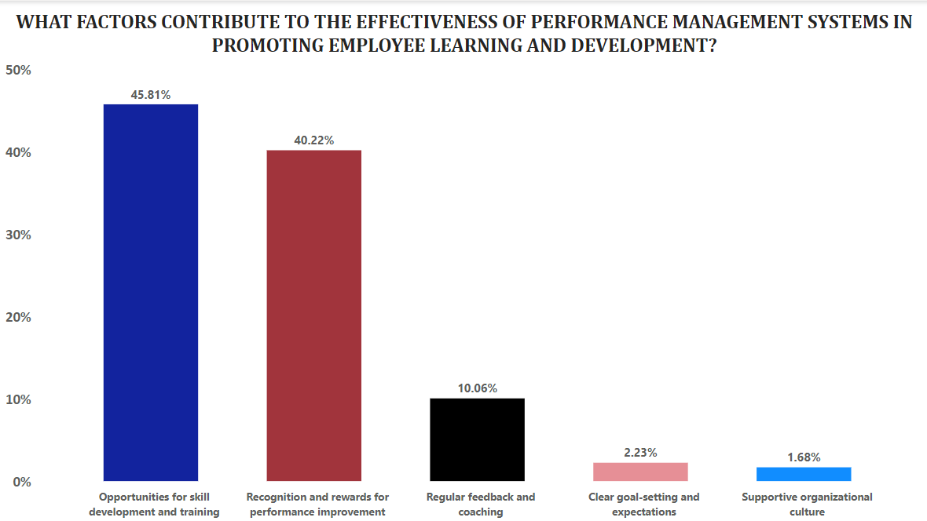

Figure 4.14 Factors that contributes to the effectiveness of PM in promoting learning

The depicted visuals above are instrumental in scrutinizing respondent insights concerning the pivotal factors contributing to the efficacy of the Performance Management system (PM) in advancing employee learning and development. A comprehensive synthesis of these visual representations yields an illuminating conclusion. Notably, two predominant factors surface as primary contributors to the perceived effectiveness of the PM system. Firstly, an impressive 45.81% of responses underscore the pivotal role of "Opportunities for skill development and training" in driving employee growth. Secondly, a substantial 40.22% of respondents accentuate the significance of "Recognition and rewards for performance improvement," highlighting its motivational influence on learning and development endeavors. Moreover, a notable contingent of 10.06% believes that "Regular feedback and coaching" significantly enhance effectiveness, reinforcing the role of consistent guidance. In a similar vein, a modest 2.23% of responses emphasize the importance of "Clear goal-setting and expectation from employees." Lastly, a fractional yet noteworthy 1.68% of responses emphasize the impact of a "Supportive organizational culture" on augmenting the effectiveness of the PM system. In essence, these collective insights underscore a multifaceted framework within which the effectiveness of the PM system is optimized, aligning with employee learning and development in a comprehensive manner.

## 4.7 Analysis and presentation of findings on Research Question 3

*What is the impact of performance management systems on employee skills enhancement, knowledge acquisition, and overall professional development within Nigerian hospitality establishments?*

Research Question 3 delves into the extensive impact of performance management systems on the enhancement of employee skills, the acquisition of knowledge, and the overarching professional development within the dynamic landscape of Nigerian hospitality establishments. A comprehensive exploration of this question aims to unearth the multifaceted influence of these systems on individual growth trajectories. By assessing the extent to which performance management systems facilitate skill enrichment and knowledge assimilation, a holistic understanding emerges, shedding light on their role in nurturing well-rounded professionals. Moreover, this inquiry delves into the wider implications, encapsulating how these systems contribute to the broader spectrum of professional development. The outcomes of this analysis potentially encompass insights into the effectiveness of training initiatives, the alignment of skill enhancement with organizational goals, and the cultivation of a learning-driven environment within the context of Nigerian hospitality establishments. Ultimately, the responses to this question illuminate the pivotal role of performance management systems in shaping the evolution of employee capabilities, knowledge assets, and holistic professional advancement within the dynamic realm of the Nigerian hospitality industry.

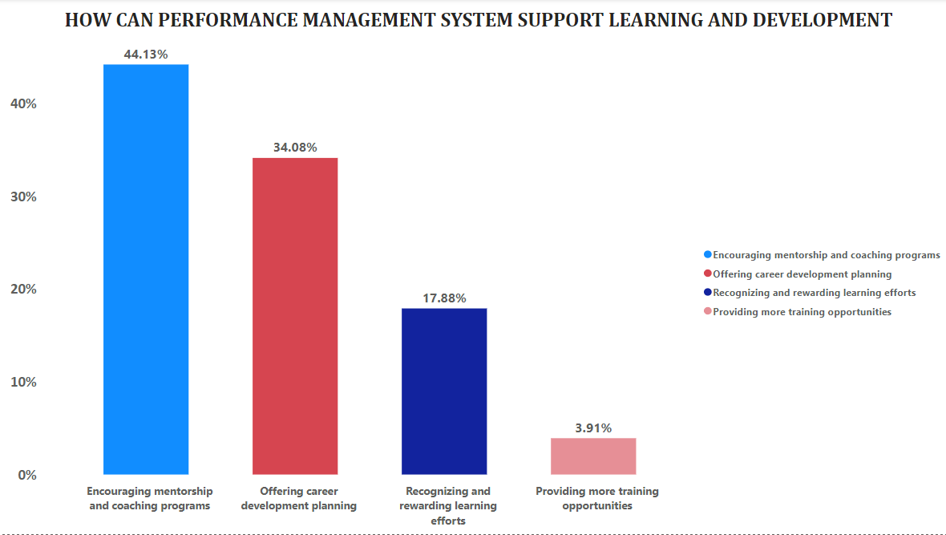

Figure 4.15 how can PM support learning and development

The presented visuals above serve as a conduit for comprehensive analysis, aiming to dissect the manner in which the Performance Management system (PM) actively contributes to fostering learning and development. A discerning examination of these visuals yields a clear and insightful pattern. Notably, a substantial majority of respondents, constituting 44.13% of the total, assert that the "Encouraging mentorship and coaching programs" stands as a pivotal mechanism to bolster the PM system's support for learning and development initiatives. Following closely, an appreciable 34.08% of respondents emphasize the value of "Offering career development planning" as a strategic pathway for enhancing this support. Furthermore, an emerging sentiment is observed, with 17.88% of responses highlighting the importance of "Recognizing and rewarding learning efforts" in cultivating a robust learning environment. Lastly, a smaller yet noteworthy fraction, totaling 3.91% of responses, identifies the potential of "Providing more training opportunities" to further reinforce the PM system's role in promoting learning and development. Synthesizing these insights culminates in a profound deduction: a multi-pronged approach, involving mentorship, career planning, recognition, and enhanced training opportunities, synergistically underpins the PM system's efficacy in nurturing a culture of dynamic learning and comprehensive development within the context of the Nigerian hospitality industry.

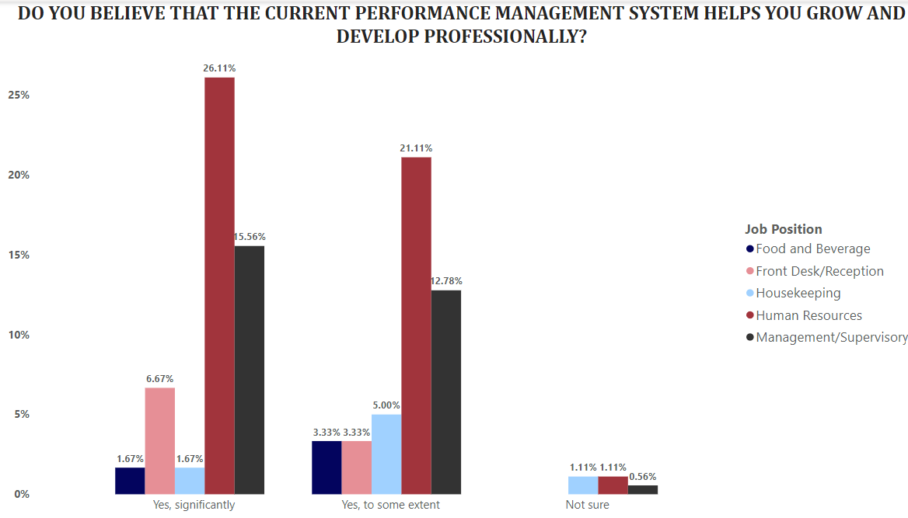

Figure 4.16 Does PM helps to employees to grow and develop professionally

The visual representations showcased above are meticulously crafted to encapsulate the diverse perspectives of respondents regarding the present state of the Performance Management system in terms of its contribution to their professional growth. A thorough analysis of these visuals offers a profound glimpse into these perceptions, yielding a clear and insightful pattern. Predominantly, an impressive majority, totaling 50.01% of the responses and prominently represented by Human Resource respondents, firmly assert that the Performance Management system has undeniably and significantly propelled their professional advancement. Further, a considerable contingent of 32.77% of respondents express a nuanced view, indicating that the system has contributed to their growth to some extent. Within this spectrum of perceptions, an additional subset holds an undecided stance, reflecting the complexity and diversity of opinions within the respondent pool. These collective insights coalesce into a comprehensive understanding: the Performance Management system occupies a pivotal role, being instrumental in propelling significant professional growth for a majority, while also fostering incremental advancement for a notable fraction. This nuanced portrayal underscores the system's dynamic influence in shaping the professional trajectories of individuals within the context of the Nigerian hospitality industry.

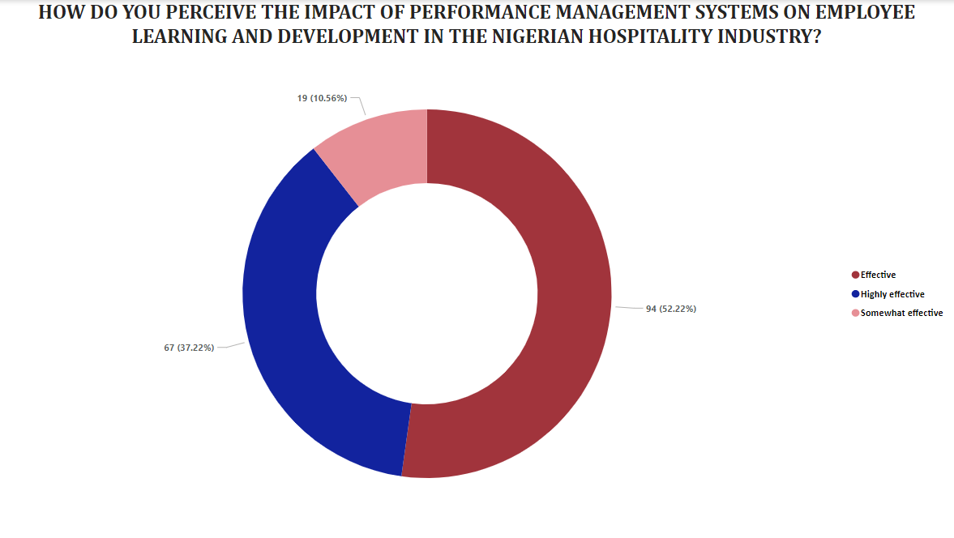

4.17 Effectiveness of the impact of PM on employees learning and development

The presented visuals above serve as a comprehensive canvas for dissecting the perceptions of respondents regarding the influence of the Performance Management (PM) system on employee learning and development. Through a meticulous analysis of these visuals, a discernible pattern emerges, shedding light on the prevailing sentiment within the respondent pool. Impressively, a notable majority, composing a collective 52.22% of the responses, assert that the PM system is deemed "Effective" in driving learning and development initiatives. Furthermore, a substantial contingent of 37.22% of responses elevates this sentiment by deeming the system "Highly Effective," underscoring its potent role in fostering skill enhancement and knowledge acquisition. Within this spectrum of perceptions, an additional subset of 10.56% holds the view that the PM system holds a "Somewhat Impactful" status. Synthesizing these insights culminates in a compelling deduction: The Performance Management system emerges as a potent force, characterized by its effectiveness and high impact, significantly contributing to the learning and development of employees. This resonant sentiment underscores the system's pivotal role in cultivating a culture of continuous improvement, aligning with the overarching goal of enhancing employee skills and holistic professional advancement within the realm of the Nigerian hospitality industry.

## 4.8 Analysis and Presentation of Findings on Research Question 4

*What are the main challenges that organizations in the Nigerian hospitality industry face when implementing performance management systems to promote learning and development, and what strategies can be used to overcome these challenges?*

Research Question 4 delves into a critical examination of the primary challenges encountered by organizations within the Nigerian hospitality industry when implementing Performance Management systems aimed at fostering learning and development. This inquiry seeks to unveil the multifaceted barriers that impede the seamless integration of such systems. By dissecting these challenges, a comprehensive understanding emerges, shedding light on factors such as resistance to change, lack of clear communication, and inadequate resource allocation. Equally vital, this exploration extends to identifying strategic pathways to surmount these obstacles. Potential strategies encompass fostering a culture of open communication, providing comprehensive training for all stakeholders, leveraging technology to streamline processes, and tailoring performance management initiatives to align more closely with the unique dynamics of the hospitality industry. The outcomes of this analysis hold the potential to facilitate a more effective implementation of Performance Management systems, thereby optimizing their role in nurturing learning and development within Nigerian hospitality establishments.

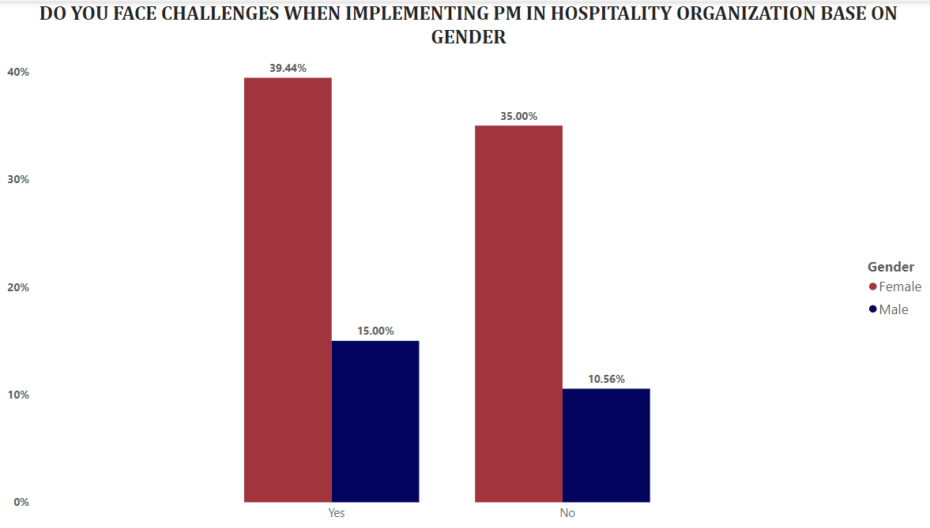

Figure 4.18 Challenges faced when implementing PM in hospitality organizations according to gender review

The visual representations presented above offer a unique lens through which to explore respondents' perceptions regarding challenges encountered during the implementation of Performance Management (PM) systems in hospitality organizations, disaggregated by gender. An in-depth analysis of these visuals reveals a distinctive pattern. Evidently, a substantial 39.44% of female respondents acknowledge facing challenges during PM implementation, while a smaller yet significant 15.00% of male respondents echo similar sentiments. Conversely, a notable 35.00% of female respondents and 10.56% of male respondents state that they have not encountered challenges in the PM implementation process. Drawing from these responses, a prevailing theme emerges: a substantial proportion of respondents, collectively forming the majority, assert that they indeed face challenges during the implementation of PM systems in hospitality organizations. This consensus sheds light on the existence of significant hurdles that necessitate resolution, reinforcing the imperative for targeted strategies to streamline the PM implementation process, enhance organizational efficacy, and cultivate a more seamless path toward achieving learning and development objectives within the dynamic realm of the hospitality industry.

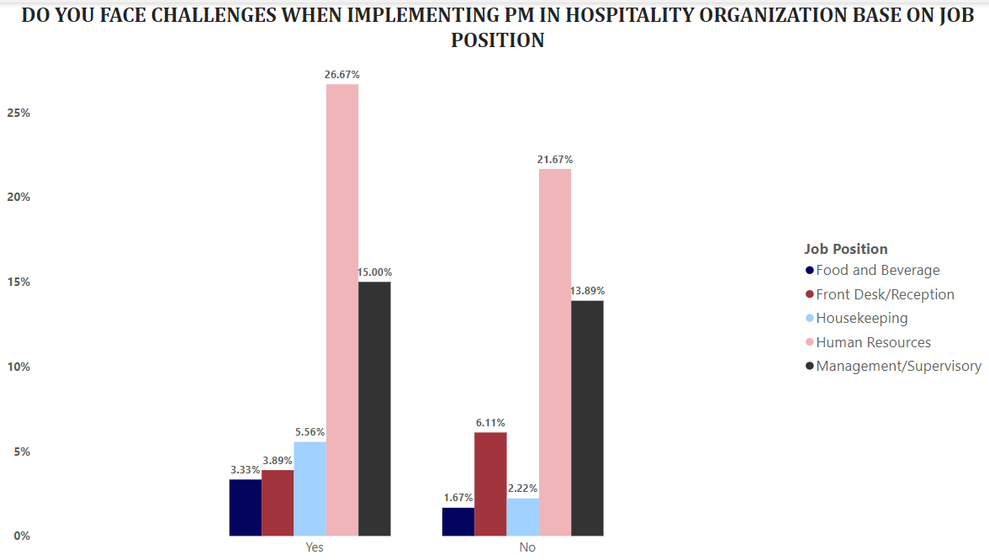

Figure 4.19 Challenges faced when implementing PM in hospitality organizations according to respondents Job roles.

The visual representations showcased above provide a compelling platform to gauge respondents' perspectives concerning challenges encountered during the implementation of Performance Management (PM) systems within hospitality organizations, segmented by their respective job positions. A meticulous analysis of these visuals reveals a diverse landscape of opinions, reflecting the varying experiences of different roles. Significantly, within the Human Resource category, 26.67% of respondents express facing challenges during PM implementation. Likewise, within the management/supervisory roles, 15.00% acknowledge similar hurdles. Notably, across specific job positions, 5.56% of housekeeping staff, 3.89% of Front Desk/Reception personnel, and 3.33% of those in the Food & Beverage sector also attest to encountering challenges during implementation. Conversely, a notable 21.67% of Human Resource personnel, 13.89% of management/supervisory roles, 6.11% of Front Desk/Reception staff, 2.22% of housekeeping, and 1.67% of Food & Beverage roles assert that they have not encountered challenges during PM implementation. Upon synthesizing these diverse responses, a resounding theme emerges: a collective 54.45% of responses affirm the presence of challenges during the implementation of PM systems across various job positions within hospitality organizations. This overarching consensus underscores the critical need for focused initiatives to address these challenges, facilitate a more streamlined implementation process, and further enhance the alignment of PM systems with the goals of promoting learning and development within the dynamic landscape of the hospitality industry.

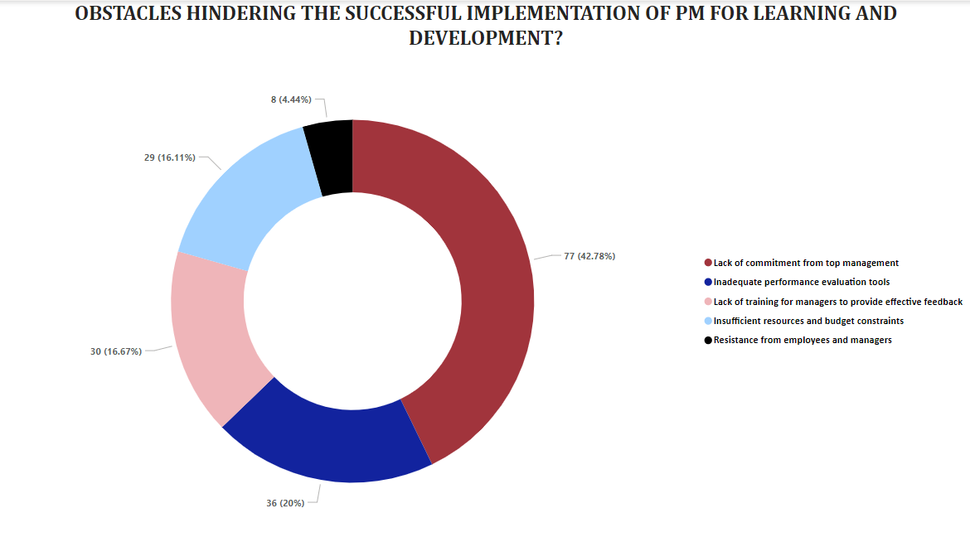

Figure 4.20 Obstacles hindering the successful implementation of PM for learning and development

The above visual representations offer a comprehensive panorama of respondent perceptions, shedding light on the predominant hurdles that impede the successful implementation of Performance Management (PM) systems. An in-depth analysis of these visuals reveals a clear and discernible pattern, encapsulating the core challenges faced. Notably, a substantial 42.78% of respondents identify "Lack of commitment from top management" as the foremost obstacle that significantly hampers the seamless implementation of PM systems. This sentiment underscores the critical role that leadership plays in driving the success of such initiatives. Following closely, 20% of responses pinpoint "Inadequate performance evaluation tools" as a noteworthy challenge, emphasizing the importance of robust assessment mechanisms. Moreover, 16.67% of respondents highlight the significance of "Lack of training for managers to provide effective feedback" as a pivotal hurdle, accentuating the vital role of skilled managerial guidance. In parallel, an appreciable 16.11% of responses underscore the impact of "Insufficient resource and budget constraints," shedding light on the resource-related challenges faced during implementation. Lastly, a fractional yet noteworthy 4.44% of responses spotlight the role of "Resistance from employees and managers" as a notable obstacle in the PM system's successful execution. Synthesizing these collective insights culminates in a compelling deduction: a multifaceted approach encompassing leadership commitment, robust evaluation tools, comprehensive training, resource allocation, and change management strategies is essential to navigate the intricacies and ensure the effective implementation of PM systems, thereby fostering a culture of learning and development within the dynamic sphere of the hospitality industry.

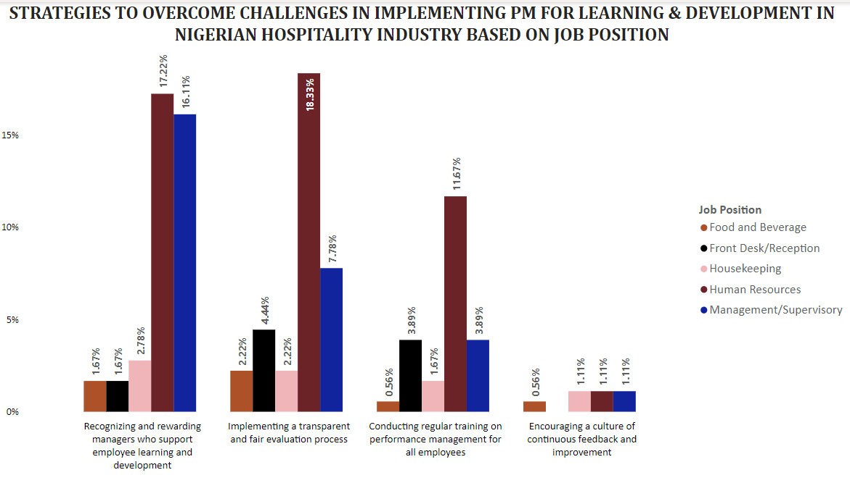

Figure 4.21 ways to overcome challenges during implementation of PM

The visual representations presented above provide an insightful panorama of the strategies contemplated by workers, employees, and managers as potential solutions to overcome challenges encountered during the implementation of Performance Management (PM) systems within their respective job positions. Through a comprehensive analysis of these visuals, a coherent and salient pattern emerges, offering valuable insights into the most favored strategies. Overall, aggregating responses from all job positions, the strategy with the highest endorsement is "Recognizing and rewarding managers who support employee learning and development," garnering a significant 39.45% of total responses. This underscores the critical role of managerial advocacy in fostering a culture of growth. Following closely, a notable 34.99% of responses emphasize the value of "Implementing a transparent and fair evaluation process," highlighting the need for equitable assessment mechanisms. Equally significant, 21.68% of responses advocate for "Conducting regular training on performance management for all employees," reflecting the pivotal role of comprehensive training initiatives. Lastly, a commendable 3.89% of responses emphasize the significance of "Encouraging a culture of continuous feedback and improvement," accentuating the role of iterative enhancement. Synthesizing these responses culminates in a compelling conclusion: a multi-pronged approach encompassing managerial recognition, transparent evaluation, comprehensive training, and a culture of feedback collectively constitutes a strategic framework to surmount challenges and optimize the implementation of PM systems, facilitating a seamless path toward cultivating learning and development within the dynamic landscape of the hospitality industry.